## 2.6 Functional View of System by Components

### 2.6.1 Registration

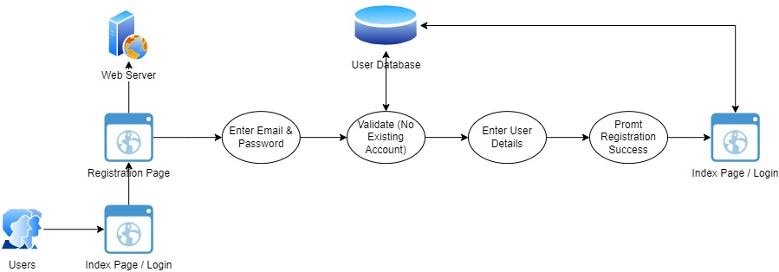

Figure 5: Registration

### 2.6.2 Home (Login & Logout)

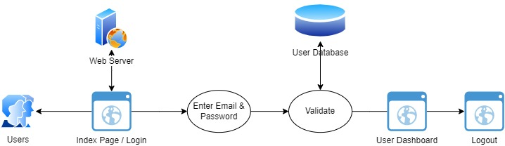

Figure 6: Home Page

### 2.6.3 Forgot Password

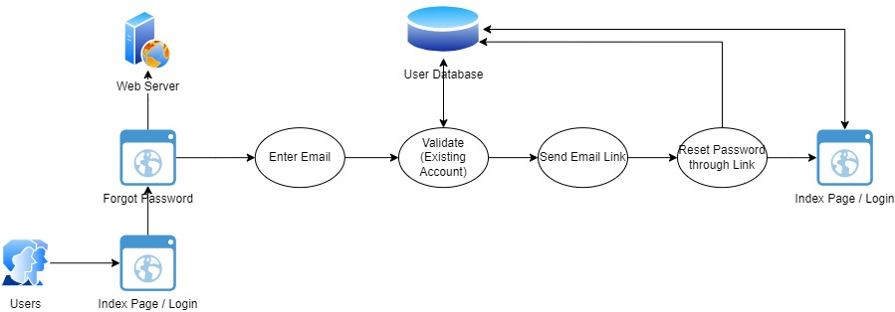

Figure 7: Forgot Password

### 2.6.4 User Details

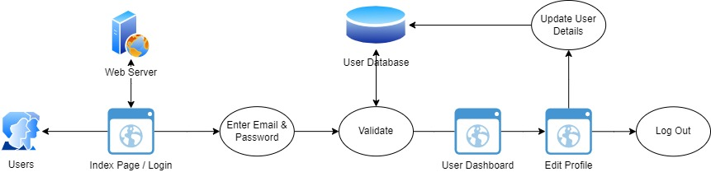

Figure 8: User Details